TFF C-PRISM Implementation

Test Strategy Document

Table of Contents
Table of Contents 2
Version History 4
Approvers/Reviewers List 4
1. Introduction 5
1.1. Project Overview 5
1.2. Document Purpose 5
1.3. Document Scope 6
1.4. Abbreviations 6
2. Test Objective 6
3. Test Approach 6
3.1. Application Functional Scope - In Scope 7
3.2. Out of Scope 8
3.3. Test Case Design Process 8
3.3.1. Responsibility 8
3.3.2. Exits Criteria 8
3.4. Test Phases - In Scope 8
3.4.1. Smoke /Sanity and BVT 9
3.4.1.1. Responsibility for Smoke / Sanity 9
3.4.1.2. Entry Criteria 9
3.4.1.3. Exit Criteria 9
3.4.2. Manual Testing 9
3.4.2.1. Responsibility 9
3.4.2.2. Entry Criteria 10
3.4.2.3. Exits Criteria 10
3.4.2.4. Suspension Criteria 10
3.4.2.5. Resumption Criteria 10
3.4.3. Integration API Testing 10
3.4.3.1. Responsibility 10
3.4.3.2. Entry 10
3.4.3.3. Exits 10
3.4.3.4. Suspension Criteria 11
3.4.3.5. Resumption Criteria 11
3.4.4. Regression Testing 11
3.4.4.1. Responsibility 11
3.4.4.2. Entry 11
3.4.4.3. Exits 11
3.4.4.4. Suspension Criteria 12
3.4.4.5. Resumption Criteria 12
3.4.5. Performance Testing 12
3.4.5.1. Responsibility 12
3.4.5.2. Test Entry Criteria 12
3.4.5.3. Success Criteria 12
3.4.5.4. Suspension Criteria 12
3.4.5.5. Resumption Criteria 13
3.4.6. UAT Support 13
3.4.7. Parallel Testing 13
3.4.7.1. Responsibility 13
3.5. Test Data 13
3.6. Test Phases - Out of Scope 13
3.7. Test Tools 14
3.8. Test Schedule 14
3.9. Customer Testing Sign off Criteria 15
3.9.1. Testing Sign off Criteria 15
3.9.2. Hyper care (Post Deployment) Sign off Criteria’s 15
3.10. Test Governance Process 15
3.10.1. Team Meetings 15
3.10.2. Test Report 16
3.10.3. Test Metrics 16
4. Defect Management Process 17
4.1. Defect Priority and Severity 17
4.2. Defect Triage Discussion 18
4.2.1. Responsibility 18
5. Testing Deliverables 18
6. Test Environments 19
7. Roles & Responsibilities and RACI Matrix 19
8. Risks and Issues 21
Appendix A 21

Document Control

Version History
Version | Author | Role | Change Details | Date
0.1 | Vimal Chauhan | QA Lead | Initial Draft | June 19, 2024

Approvers/Reviewers List
Name | Role | Approver/Reviewer
Kiran Kumar | PM | Reviewer
Prashant | PM | Reviewer

Introduction

Project Overview

TForce Freight is seeking to replace their legacy Freight Pricing and Rating applications and has requested the assistance of Coforge.
Coforge will implement the Pegasystems (“Pega”) platform and provide an application (“COFORGE-PRISM”, “C-PRISM”) designed and configured on the Pega platform, which, only when combined provides a functional solution (the “Solution”) for TFF. The Solution will replace existing applications used by TFF to support the Freight Pricing and Rating function, providing TFF with functionality not available today as well as other business benefits associated with Freight Pricing and Rating.
C-PRISM will be implemented to deliver accurate pricing per Customer Pricing Programs by taking several rating logics into consideration while following industry standards. Implementation of PRISM provides TForce the readiness to support industry shifts towards new rating types and a flexible architecture which can evolve with market trends.
C-PRISM will:
- Provide the ability to support new rate types, auto rate bills with all the new rating types, and auto rate domestic and offshore shipments
- Validate rules to reduce human errors and enable a flexible design
- Provide a more user-friendly process for pricing program analysts and their support teams.
PRISM will provide the simplicity of creating and maintaining Pricing Programs, including auto rating freight bills, enabling automated quotes, and automation of accessorial and fuel surcharge calculations. Automating these processes will allow reduced Pricing Program errors, but above all, improve customer and end user experience.
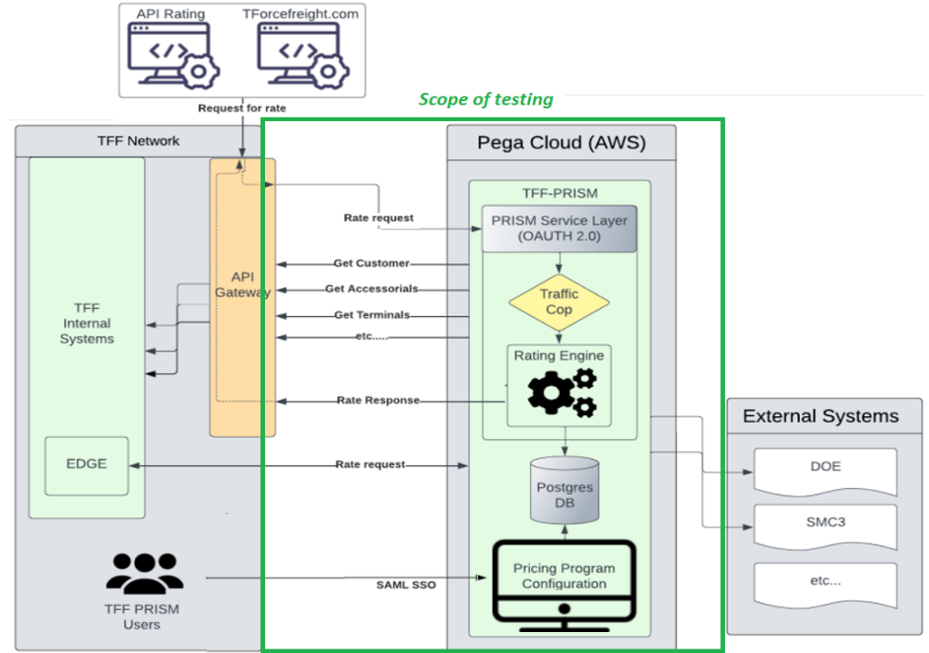

Document Purpose
The Test Strategy is a program wide document, which applies to the C-PRISM program delivered by Coforge teams.

The approach to be adopted for the testing activities and for each test stage will be elaborated to describe the deliverables, pre-requisites and responsibilities for each test stage including test coverage and test planning for each of the phases.

Document Scope
The objectives of this document are to:
- Provide visibility to all stakeholders of the testing approach, including Defect Management and Reporting.
- Provide a high-level view of the test scope.
- Give clarity on all proposed Test Phases, their objectives, ownership, and Entry/Exit Criteria.

Abbreviations

Abbreviation | Full
E2E | End-to-End
QA | Coforge Quality Assurance Team
IT | Information Technology
SDLC | Software Development Life Cycle
SIT | System Integration Testing
ADO | Azure Dev Ops
UAT | User Acceptance Testing
BVT | Build Verification Testing
DM | Data Migration Team
KT | Knowledge Transfer
BA | Business Analyst
PM | Project Manager

Test Objective

The objective of the test is to verify that the functionality of the C-PRISM application works according to the specifications. The testing team will create, execute, and verify the test cases (both manual and automated tests) and report defects for failed scenarios.
Sprint team will triage all reported defects along with SME’s and prioritize. Post defect triage they are bucketed as Sprint backlog or Product backlog items, and they are scheduled for fix.
Performance Testing will include the below initiative:
- Execute Incremental Load test with different Workload profile distributed between Rating API operations.
- Execute test at a peak load to observe the behaviour of the application.

Project Testing Approach

The project will follow the Agile methodology, emphasizing iterative and incremental testing throughout development. It involves close collaboration between testers, developers, and stakeholders, enabling continuous feedback and frequent testing cycles. This approach is applicable for new application development.

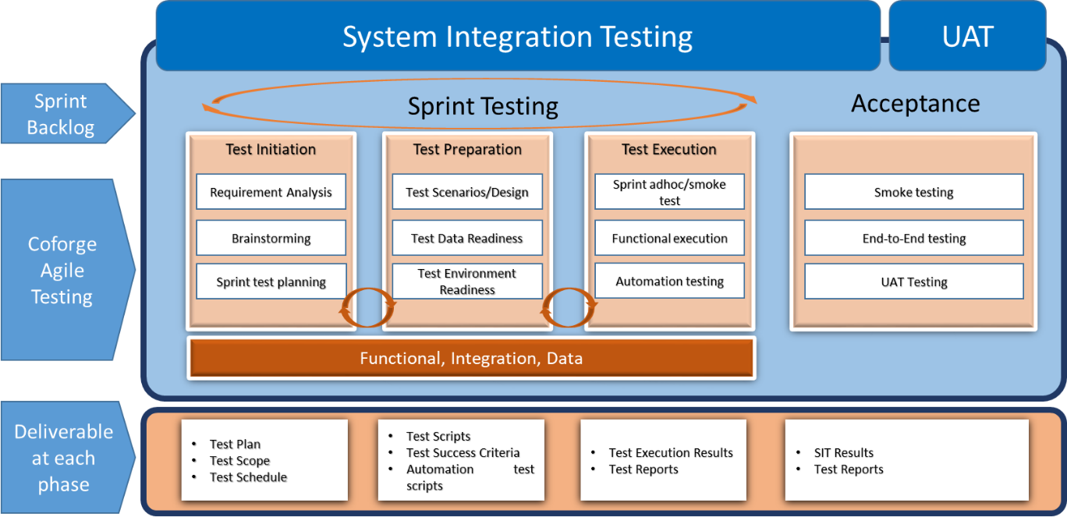

Automation Regression-Based Approach to focus on ensuring that modifications or enhancements to the software do not introduce new defects or impact existing functionalities. Regression testing validates system stability after changes. This approach is applicable for all change requests and bug fixes.

Analytical Approach applicable for Data migration and Parallel testing scenarios. Analyse requirements, risks, and critical functionalities to determine the testing scope and prioritize test activities accordingly. Hybrid testing approach used for integration testing.

There are seven 2-week sprints planned for the build / configuration phase of the C-PRISM implementation. Each phase of the project will have set of activities along with responsibility and exit criteria, which are described in this testing strategy document.

Below listed are high level activities across the sprints:
- Analyse and understand the functionality / requirements from user stories.
- Participate in Sprint grooming and brainstorming sessions.
- Design Test Cases, reuse, and scale existing test cases from previous sprints.
- Internal Test Case reviews by functional SMEs
- Automation suite creation, execution, and maintenance
- API test suite creation, execution, and maintenance
- Preparation of Test data.
- BVT testing to ensure stability of build.
- Defect reporting, retesting the fixed bugs to check for existence and validate impacted areas.
- Review, validate and execute test cases, broadcast the test execution reports.
- Scalability Testing: Target to validate C-PRISM Rating API services when user load incrementally grows on the system.
- Load Testing: Target to verify C-PRISM Rating API services under peak load conditions.

Application Functional Scope - In Scope

This section defines the C-PRISM application functional scope, which "will" be tested for different types of testing.
Major Areas of Application.
- Pricing
  - Custom Configuration
  - Pricing Creation Workflows
  - Calculation methods
  - Fuel Surcharge
  - Data migration functional testing with Data sampling approach
- Rating
  - Rate API
  - Rate UI
- Integration
  - Total of 15 APIs in the scope. (Appendix A)
  - Detail covered in Integration testing section.

Out of Scope
- Any / all system updates outside of C-PRISM
- Any / all integration adds or updates outside of Pega / C-PRISM
- Preparation of other systems and test data needed for all test phases.
- Testing for any system outside of C-PRISM
- Any reports not included in OOB C-PRISM reports
- List of requirements Out of scope or planned for future release provided in separate document.

Test Case Design Process
The activities in this phase include test case design for functional testing (manual & automation) and non-functional testing (scripts for performance testing).
Post sprint user story grooming session, Design activities will be initiated, for various phases of testing in scope.

Responsibility
Coforge QA team will be responsible for the Test Design activities and will cover the listed activities:
- The team will create the Test Cases for in-scope User Stories and will cover all positive, negative, boundary value test scenarios and follow Coforge test case design standards and guidelines.
- Post the test design, Peer review will be done by the testing team. BA will review and approve the test cases.
- Reviewed test cases are uploaded to Azure DevOps tool and linked up with respective user stories.
- The team will create QA Tasks as a “Child” link of User story in ADO. All the reviewed test cases must be “link” as “Tests” child with User Stories.

Exit Criteria
- Test cases are designed and reviewed against acceptance criteria and approved by the business analysts
- Test cases and results are uploaded to Azure DevOps (ADO)

Test Phases
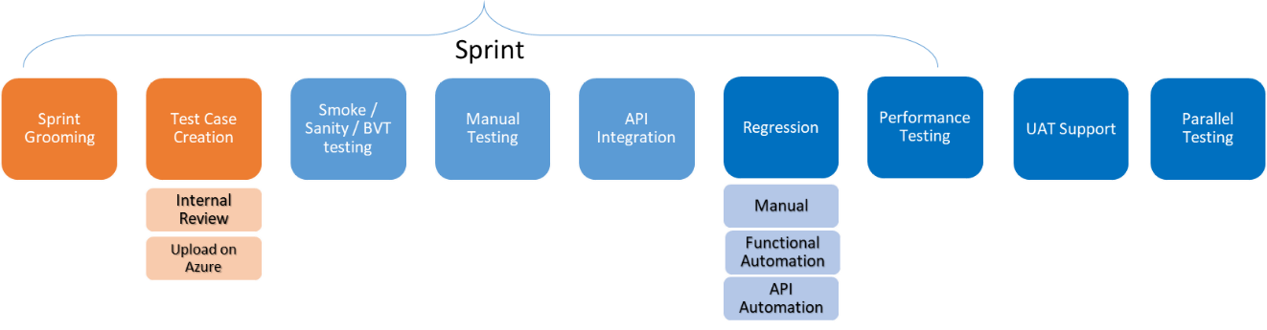
The test execution phases start with the kick-off meeting for each phase. The below-mentioned process will be applicable for the different types of testing and will be aligned to the overall phases of the product implementation.
The initial phase is focused on Sprint grooming, user story brainstorming and test design activities. Coforge QA team start with testing execution activities as soon as build deployed in respective QA/Stage 1 environment. Here are further details on different test execution activities in overall phases.

Smoke /Sanity and BVT
Manual Smoke / Sanity will be conducted to verify that each in-scope function is deployed with all required components and accessible to all target business users including testing team.
BVT will complement the manual Sanity ensuring build stability.

Responsibility for Smoke / Sanity
Coforge QA team will be responsible for the Smoke / Sanity (Manual / Automation) and will cover the listed activities:
- The test team will Identify Manual smoke/ sanity test from the test case repository and store the cases in ADO Task.
- BVT Test Suite will contain limited number of automation scripts for Pricing Programme creation.
- Creation and Identification of test data.
- Test Team will execute the identified manual test cases and update the result in respective QA Task within ADO.
- Retest the defects.
- Automation team shared the BVT execution report with-in Coforge teams for observed failures / successes.

Entry Criteria
- Build deployed in QA / stage 1 environment.
- Development Team complete unit testing.
- Sanity scenarios identified.
- Test Data created / identified.
- Task created in ADO.
- BVT Automated Test Scripts are ready for execution.

Exit Criteria
- Identified sanity scenarios executed with successful result.
- No blocker defect observed.
- BVT tests are successful.

Manual Testing
The main purpose of this testing is to verify that the software meets acceptance criteria of user stories. Based on sprint scope and backlog (user stories) scope of manual testing is defined.

Responsibility
Coforge QA team will be responsible for the Manual testing and will cover the listed activities:
- The team will execute the defined / identified test cases.
- Creation / Identification of test data.
- Participate in defect triage along with BA Team for appropriate priority and severity and status of identified defects.
- Re-testing of the fixed defects.
- Execution of identified regression scenario for sprint N-1 for impacted functional areas.
- Test Result and evidence update in ADO Task

Entry Criteria
- Designed test cases are uploaded on ADO tool and associated with respective user stories.
- Successful completion of Smoke / Sanity testing.
- Test data created / identified.

Exit Criteria
- All planned test cases executed.
- No P1 and P2 defects remains open.
- Post defect triage meetings, defects or enhancement to be consider for backlog item on project need basis.

Suspension Criteria
- Identification of blocker defects (priority 1 defect).
- Test environments are not available.

Resumption Criteria
- Testing will resume once the problem blocking the test execution is rectified.

Integration API Testing

Integration testing for API is performed in parallel to functional testing. Based on sprint scope and backlog (user stories) scope of integration testing is defined.

Responsibility
Coforge QA team will be responsible for the Integration testing and will cover the listed activities:
- Manual API Integration testing
  - Creation / Identification of test data.
  - Test team will execute all the identified, designed test cases from ADO and update the result in respective QA task within ADO.
  - Participate in defect triage along with BA team for appropriate priority and severity and status of identified defects.
  - Re-testing of the fixed defects.
- Automation API testing with Postman tool
  - QA team leverage the Postman tool for API Integration testing.
  - The test team design the Postman test scripts for all sprints user stories.
  - Test team execute all the API test scripts for the said sprint.
  - The test team identify the Integration tests from the Regression Suite and executes tests for sprint N-1 for impacted functional areas.

Entry Criteria
- All the manual test cases identified and associated in ADO.
- Automation API test scripts are created.
- Test data created/ identified.

Exit Criteria
- All the planned identified test cases executed.
- All the planned designed automation test scripts executed.
- No P1 and P2 defects remains open.

Suspension Criteria
- Identification of blocker defects.
- Test resources (Tools and Environments) are not available.

Resumption Criteria
- Testing will resume once the problem blocking the test execution is rectified.

Regression Testing
Continuous Regression testing in every sprint is done to ensure that the functional development in subsequent sprints have not introduced defects to areas for which testing is completed.

Responsibility
Coforge QA team will be responsible for the Regression testing in each sprint and will cover the listed activities:
- Both Manual and Automation Regression testing will be performed for each sprint. Team will adhere to Coforge regression testing practices.
- Team requires to build the automation framework using Selenium tool ensuring that framework support:
  - C-PRISM application functional flows
  - Regression testing, Build verification testing (BVT)
  - Multiple test environments like Stage-1, Stage-2.
- Critical and common flows will be automated rather than 100% automation to ensure effective coverage. Those will include:
  - Create Standard Pricing Program
  - Account search and creation of Pricing Program Type
  - Creation of Pricing program for all calculation methods
  - Business critical scenarios.
  - Integration functional flows
- Manual and Automated Regression Test Cases / Scripts for each sprint will be identified from the Test Case Repository maintained in ADO.
- Identification / creation of test data requirement for successful execution.
- Continuous regression execution (Manual + Automation) in QA environment (Stage-1) for each sprint.
- Participate in defect triage along with BA Team for appropriate priority and severity and status of identified defects.
- Re-testing of the fixed defects.
- Test Result and evidence update in ADO Task
- Defects logged in Azure DevOps

Entry Criteria
- Functional testing completed with execution of all planned test cases.
- Regression Test Cases are identified, and necessary scripts are in place.
- Automation framework is up & running to cater newly deployed sprint.
- Test data identification and data creation completed.

Exit Criteria
- All planned test cases (automation & manual) executed.
- Test Exit Report must be shared with all stake holders.
- All unresolved defects must be discussed with BA and prioritized.

Suspension Criteria
- Application/Subsystems are not available on specified schedule.
- Application does not work or fails to launch, or any showstopper found that does not allow tester to further use the system.
- Test resources (Tools and Environments) are not available.

Resumption Criteria
- Testing will resume once the problem that is stopping the testing to continue is rectified.

Performance Testing
The performance testing will be performed on final build after completion of all the sprints. Objective is to determine the system parameters in terms of responsiveness and stability under varied workloads. Performance test environment would be production like in terms of hardware and software configurations and setup.

Responsibility
Coforge QA team will be responsible for the Performance testing and will follow different set of performance testing activities in respective phases:
- dScope of Performance Automation includes:
  - Rating API functionality is in-scope of the C-PRISM performance testing.
  - Different type of performance tests executed under combination of input attributes.
- Performance Test Design (Scripting Phase)
  - Identify Performance scenarios, Script creation, review, and verification.
  - Test data readiness and verification.
- Performance Test Execution Phase
  - Baseline the application response times, throughput rates, resource utilizations (CPU/Memory) under 50%-70% of normal load conditions.
  - Load testing with gradual ramp-up, with a target load of 850K calls per day.
  - Stress Testing with constant number of calls (around 1500 to 2000 calls per minute) for around 1hrs time limit.
  - Execution with increased volume of 10-15% with system Monitoring.
- Completion Phase
  - Address identified performance bottlenecks.
  - Creating the Performance test completion reports.

Entry Criteria
- Identified Requirements
- A production like dedicated environment
- Stability of C-PRISM tool.
- Availability of tools

Exit Criteria
- C-PRISM application has a performance rating of less than 1 second (without the inclusion of the response times of any other internal or external integrations) to return rate requests.
- 850k rating request API calls per 24 hour period
- 35 to 50 simultaneously user using C-PRISM application.

Suspension Criteria
- Identification of critical defect while Performance testing
- Test environment failures.

Resumption Criteria
- Testing will resume once the problem is rectified.
- Coforge QA will re-execute the performance script as per the need.

UAT Support
UAT testing is out of scope of Coforge QA team. However, team will provide require support in terms of identification of Test Scenarios for UAT along with Business Team.
Coforge team will continue with testing efforts towards Defect triage, Defect retesting, Defect verification and Impact area regression.

Parallel Testing
Parallel Testing objective is to do comparative testing between the Legacy system and C-PRISM system ensuring the business rules for Pricing program and implemented prices with Rating API are same.

Responsibility
TFF team will be responsible for testing the identified set of test cases in legacy environment whereas Coforge team will be responsible for testing the same set of test cases in C-PRISM.
Following activities will be performed by both teams:
- Coforge team to identify tests, to be approved by the TFF Test Team.
- Identified Tests cases to be uploaded in the ADO QA Task.
- Execution of test cases in legacy environment (by TFF Team) and C-PRISM (Coforge) to verify pricing data with data sampling.
- Result comparison to be done by both TFF and Coforge team.
- Re-testing of the fixed defects.
- Test Result and evidence update in ADO Task

Test Data
Testing team will create / identify test data as per user story and test case requirements in discussion with SMEs.
- Regular connect with BA Team and development team to understand the data dependency for the test cases / scripts.
- Team will leverage automation tool for test data generation.
- Automation team will consider shorter date range for Effective and Expiration dates while creating Pricing programs.
- Coforge QA team to use proper naming conventions for test data.
- For the Rate tariff data, team will leverage the data provided from SMC3 integration.
- Team will use proper “business attributes” for creating Global Do Not rate rules.
- For the Performance testing, team will leverage the data provided by TFF for data migration.
- Team will utilize “Copy pricing program” functionality to reuse the already created pricing program.

Test Phases - Out of Scope
Following types of testing are considered as out of scope for C-PRISM implementation program. Data base testing - Testing the database is out of scope for the QA team.
- Security, Penetration Testing
- Multilingual testing
- Scalability Testing
- Localization
- Accessibility
- Compliances (PCI etc.)
- Mobile
- Compatibility testing.
- UAT Testing

Test Tools
Following is the list of tools being used by the team during testing:
Tool | Test Phases | Comments
Azure DevOps https://dev.azure.com | Test Management | Where ADO is applicable- SIT, Regression and UAT will be managed in ADO
MS Teams SharePoint | Project Artefacts Repository | Created by PM on Coforge for storing all Artefacts
Selenium | Regression Testing-Automation tool | Ownership lies with Coforge team
Postman | API Integration Testing- API Test Automation tool | Ownership lies with Coforge team
JMeter | Performance test tool | Ownership lies with Coforge team
Grafana / Datadog | Performance monitoring tool | Ownership lies with Coforge team

Test Schedule
Test schedules of all work streams are shared with QA team.
Tasks | Start Date | End Date | May | June | July | Aug | Sep | Oct | Nov
QA Testing | 6-May-24 | 26-Oct-24
Automation Testing | 27-May-24 | 12-Nov-24
Automation Framework Design | 27-May-24 | 21-Jun-24
Automation Test scripts creation | 3-Jun-24 | 2-Aug-24
API Automation Test scripts creation | 3-Jun-24 | 2-Aug-24
Automation Executions | 10-Jun-24 | 25-Oct-24
API Automation Executions | 10-Jun-24 | 25-Oct-24
Automation Test reports | 3-Jul-24 | 26-Oct-24
Automation Handover | 26-Oct-24 | 12-Nov-24
Completion of Test plan | 6-May-24 | 24-May-24
Internal review of Test plan | 27-May-24 | 5-Jun-24
Sprint 1 Test Case Creation / Execution | 22-May-24 | 4-Jun-24
Publish Sprint 1 test report |  | 11-Jun-24
Sprint 2 Test Case Creation / Execution | 5-Jun-24 | 11-Jun-24
Publish Sprint 2 test report | 5-Jun-24 | 18-Jun-24
Sprint 3 Test Case Creation / Execution | 19-Jun-24 | 2-Jul-24
Publish Sprint 3 test report | 19-Jun-24 | 2-Jul-24
Sprint 4 Test Case Creation / Execution | 3-Jul-24 | 16-Jul-24
Publish Sprint 4 test report | 3-Jul-24 | 16-Jul-24
Sprint 5 Test Case Creation / Execution | 17-Jul-24 | 30-Jul-24
Regression testing (Manual / Automated) | 17-Jul-24 | 30-Jul-24
Publish Sprint 5 test report | 17-Jul-24 | 30-Jul-24
Sprint 6 Test Case Creation / Execution | 31-Jul-24 | 13-Aug-24
Regression testing (Manual / Automated) | 31-Jul-24 | 13-Aug-24
Sprint 6 test report shared | 13-Aug-24 | 13-Aug-24
Sprint 7 Test case execution | 14-Aug-24 | 27-Aug-24
Regression testing (Manual / Automated) | 14-Aug-24 | 27-Aug-24
Sprint 7 test report shared | 27-Aug-24 | 27-Aug-24
UAT test scenarios shared with TFF | 11-Sep-24 | 22-Oct-24
Smoke / Regression Testing | 28-Aug-24 | 10-Sep-24
Execute smoke test scenarios | 28-Aug-24 | 10-Sep-24
Parallel Testing | 28-Aug-24 | 10-Sep-24
Verify issues fixed and close | 28-Aug-24 | 10-Sep-24
Regression testing (Manual / Automated) | 28-Aug-24 | 10-Sep-24
Defect Triage on Smoke / Regression defects | 28-Aug-24 | 10-Sep-24
TFF Signoff on Sprint 7 scope demoed |  | 10-Sep-24
Performance Testing | 22-May-24 | 18-Oct-24
Authoring Performance test scripts | 22-May-24 | 18-Jun-24
Execute first round of performance test | 19-Jun-24 | 2-Jul-24
Fix performance issues found after initial test | 19-Jun-24 | 2-Jul-24
Execute second round of Performance test | 3-Jul-24 | 16-Jul-24
Execute final round of Performance test | 7-Oct-24 | 18-Oct-24

Customer Testing Sign off Criteria.

Testing Sign off Criteria.
- No outstanding Priority 1 or 2 defects in any phase of testing.
- All planned functional/integration/regression test cases are 100% executed. Test results are updated in Azure DevOps
- Test Execution Summary Report for every sprint shared and approved by the customer.

Hyper care (Post Deployment) Sign off Criteria’s.
- C-PRISM 8-week support post deployment with no P1 / P2 identified in production.
- Maintaining a Pega Guardrail score of 90 or higher throughout the engagement, which includes the Hyper care period.

Test Governance Process
This section details the key processes employed within the QA function to keep a check and control of the applications getting migrated, defect management during support of all the migrated applications.

Team Meetings
Regular team meetings will be scheduled to monitoring the overall program according to the given frequency.

Report / Meeting | Frequency | Meeting Host | Target Audience and Stakeholders
Cross-functional forum | Daily | Project Manager | Dev, QA, BA team.
Internal QA Meeting | Daily | Test Specialist | Test Team
Defect Review / Triage | Weekly | Test Specialist | Test team, BA team, Dev team
Joint Program Status Meetings | Weekly | Project Manager | Coforge Dev and Test leads. TFF Tower heads
Sprint Demo | Sprint | Project Manager | Coforge Dev and Test leads. TFF Tower heads
Sprint Grooming | Sprint | Project Manager | Coforge Dev and Test leads. TFF Tower heads

Test Report

Coforge Testing Team will publish following reports as per proposed frequency. Ideally, these reports should be automated as much as possible.

Report / Meeting | Frequency | Description | Owner
Sprint Test Completion Summary Report | Sprint | This will highlight the overall scope of sprint. This includes total number of user stories delivered, total number test cases created and executed, identified defect with status details.  Provide progress on automation regression test suites, execution proceedings.  Highlight any challenges and risks. | Test Manager

Test Metrics
The below metrics will be captured for each application in QA, Stage 1 Environment

No. | Metrics | Description | Frequency
1 | User Story Status | Metrics to capture number of user stories completed | End of Sprint
2 | Defect Metrics | Defect by Priority Metrics- No of defects identified based on priority  Defect by Severity Metrics- No of defects identified based on priority  Defect Status- No of defects based on the Status | End of Sprint
2 | Test Case Execution Status | This metric is used for tracking the test case execution | End of Sprint
4 | Automation Coverage | This metric is useful to track the number of automation scripts created and executed within the sprint | End of Sprint

Defect Management Process
Defects will be managed in the ADO.
Test lead will set up the defect triage meeting with BA, PM and the respective application owner to discuss on all the open defects.
A simple indication of the defect management process is as depicted below:
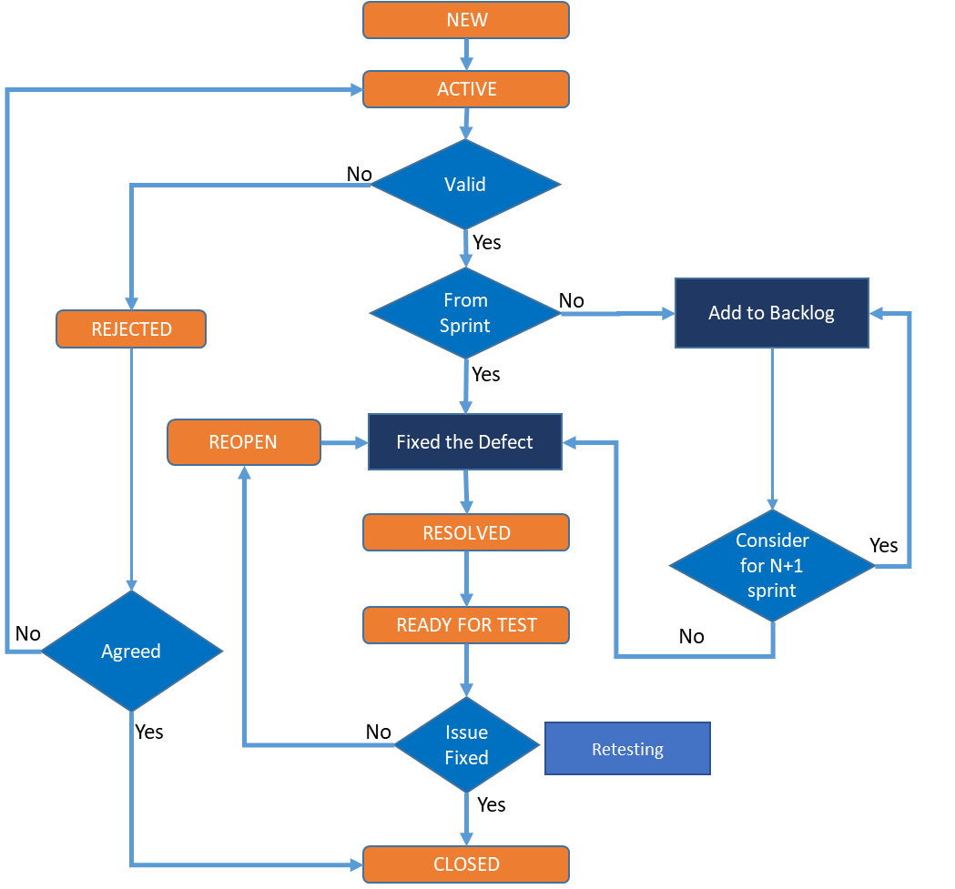

Defect Priority and Severity

Fix Priority (In ADO) | Impact on Testing
Urgent (1) | Testing blocked completely - testing cannot continue until a fix is made available.
High (2) | Testing blocked to a significant level - many test scenarios blocked until a fix is delivered.
Medium (3) | Workarounds for impacted test cases are available for high priority test cases or are blocking only low priority test cases - only one test or a small number of test scenarios blocked until a fix is delivered. The defect may only be fixed if sufficient resources and time are available before the end of the test phase.
Low (4) | Minimal or no impact on the ability to continue testing - impact is insignificant; thus, can be deferred until more pressing fixes have been delivered.

Severity (In ADO) | Impact on the Business
1 - Critical | Critical to Business operations and or services – a defect which:  - Prevents large numbers of users from accessing the software (including unavailability)  - Would have a significant adverse effect on external customer or key business user experience.
2 – High | Significant Business Impact – a defect which:  - Impacts the use of one or more critical components of the software by groups of users (including external customers).  - Has no manual workaround.
3 – Medium | Manageable Business Impact – a defect which impacts the use of one or more non-critical or critical components of the software by at least a single user, and where: an acceptable manual workaround exists.
4 – Minor | Limited Business Impact - Any other defect not being classified which affects the software, including cosmetic problems, user requests for information.

Defect Triage Discussion
In this process Coforge Test team, Dev leads, and BA teams will validate the priority, severity of the identified defects along with root cause. Team will also discuss and recommend if defect require to be fix in the current sprint or can be considered for later sprint.

Responsibility
QA Lead will be responsible for the defect Triage along with BA and Dev lead. Following are the activities covered during the meetings.
- Test Team conduct the Defect triage discussion within sprint testing.
- Conclude if defect is correct or otherwise mark the defect as “Invalid” or “As Design”.
- Assign the correct Priority / severity.
- Conclude the fixing timeline and impact.
- Conduct root cause analysis for defects.

Testing Deliverables
The test deliverables list below is produced for the respective test phases of each wave.
Id | Deliverable Name | Description
TD01 | Test Approach (This document) and Performance test strategy | Defines the detailed test approach, including scope, deliverables, resourcing, and specific acceptance criteria to be adopted for the relevant test phases
TD02 | Test Scenarios and Test Cases in ADO tool | Test cases consisting of a test objective, pre-condition and expected results. QA Team upload the cases in Azure DevOps.
TD03 | Automated Framework and Test Scripts | QA Team upload the cases in ADO tool.
TD04 | API Automation Test Script | API test scripts created in postman tool.
TD05 | Performance test script and report | Performance test scripts in JMeter.
TD06 | Test Summary Report | A consolidated Test summary report will be produced for each phase summarized the outcome of testing.
TD07 | Defect Summary Report | QA Team upload the cases in ADO

Test Environments
Following are the test environments available for use:
Environments | Description
Stage-1 (QA) | - Used for on-going sprint testing.  - BVT script execution  - Automation Framework designing, Scripts creation, Script Execution and API scripts creation.  - Use (N-1) sprint code base.  Regression (automation, API & manual) and end-to-end scenarios execution.
Prod / Stage 2 (Performance testing environment (replica of production)) | - Used for Performance  - Used for final Data Migration testing

Roles & Responsibilities and RACI Matrix

Role | Responsibilities
Project Manager | - Manage overall activities, agreeing and tracking plans with all internal and external stakeholders, tracking project against initial timelines.  - Own the deployment of code across all environments, including testing.  - Own, manage and provide governance on deployments to production.  - Liaising with Business owners to agree on test timeframes and resource commitment.  - Review and approve test approach document.
QA Lead | - Co-ordinate deliveries of respective test phase incl. daily activity  - Produce the Test Approach and detailed test schedule for respective phases.  - Work with PM and BA for the testing signoff and evidence in Test Environment  - Produce the Test Summary Report for the respective phase.  - Participate Defect Triage calls with PM and explain / reproduce any defects related to their test phase.  - Participate and produce supporting material and evidence for entry and exit meetings relating to test phase.  - Escalate any blockers issues with environments, data, or resources with the PM.
Functional Automation Test team | - Own the automation testing process. Take ownership on functional automation and API integration automation.  - Create the automation framework and test scripts.  - Responsible for test automation execution, provide test result evidence.  - Involve in sprint backlog and user stories discussion.
Performance Tester | - Own the Performance testing process.  - Create the performance test scripts and execution.  - Responsible for performance test reporting and coordination with PM, Dev and BA team.
Manual Functional Test team | - Owning the Manual functional testing process.  - Responsible for manual test case creation and execution.  - Involved in Defect triage discussion.  - Involved in manual regression testing.
Business Analysts (BA) | - Provide all the detailed requirement documents, user stories and acceptance criteria.  - Review and approve all the test scenarios.  - Ensure required trainings for the testing teams (SIT and UAT)  - Approve Test Summary Report  - Provide Go / No-go decision
Action​ | QA Lead​ | Dev Lead | BA Team​ | Data  Team | Manual Testers​ | Build Team​ | Business  Process owner​
Testing Strategy definition​ | R/A​ | I​ | I​ | I​ | I​ | I​ | I​
Data load strategy definition​ | I​ | I​ | -​ | R/A | -​ | C​ | C​
Test Strategy approval​ | C​ | I​ | I​ | I​ | -​ | I | A​
Data Load to the system​ | I​ | C​ | I​ | C​ | I​ | R​ | I​
Data Validation ​ | I​ | C​ | I​ | R | - | C​ | C​
Unit Tests cycle ​ | I​ | R/A | -​ | I​ | -​ | I​ | I​
User Requirements​ | R | R​ | R/A​ | I​ | I​ | -​ | C​
Test Case Preparation​ | R/A | C​ | C | I​ | R​ | - | I
Data Preparation | R/A | C | C | C | R | - | I
Test Execution | R/A | C​ | C | C​ | R​ | i​ | I​
Test Closure​ | R/A | C​ | I​ | I​ | I​ | I | C​
Parallel Testing Execution | R/A​ | C | C | I | R | -​ | A
Parallel Testing Closure​ | C | C​ | C | I | - | -​ | R/A​

Risks and Issues
Risk# | Description/Cause/Consequence | Likelihood | Impact | Mitigating Action | Owner
R001 | Test environment connectivity with test data for all the in-scope applications are not confirmed yet. Delays will impact the testing schedule and test coverage. | 3 | 5 | Increase testers, reduce scope, or extend the schedule as agreed by project owners. | Dev
R002 | Availability of Support teams for investigation, code update, defect fix is critical, and any delays will impact test schedule and may require additional time for completion of planned tests. | 3 | 4 | Regular defect triage discussion, effective notification for any blocker. | Dev, BA

Issue / Dependencies# | Description/Cause/Consequence | Criticality | Resolution
I01 | Timely sign off the Requirements, User Stories. | Medium | Regular grooming sessions, start early testing.

Assumption | Description/Cause/Consequence
A01 | Any additional or change in scope will be analysed and additional efforts will be required.
A02 | Build frequency for Dev/QA environment. Build deployment requires to done by post evening time IST.
A03 | To support the execution of 800-900k volume, we might require running multiple execution instances.
A04 | Impact to scripts due to application defect fixes from project team will require additional time for re-scripting and executing the tests.
A05 | To stimulate the peak hour’s traffic, we need to plan the performance test execution along with (in-parallel) to manual, automation, API automation in performance environment.

Appendix A
Integrations | OOB / New | Usage | Type
Customer Search Related | OOB | Used in Pricing Program Code for Account search so that accounts can be added to the pricing program | REST
Customer Search Basic | OOB | Used in Pricing Program case for Account search so that related accounts can be added to the Pricing program. | REST
Get Sales Rep List | OOB | Used as a source for Salesperson field in Account Search screen in Pricing Program | REST
Get Terminal List | OOB | Used as a source in the Terminal ID field in Pricing Program | REST
Accessorial list | OOB | Used as a source for Accessorial Code field in the Pricing Program | REST
SMC3 Available Rate Tariff | OOB | Used as a source for Rates Tariff for class-based pricing configuration in Pricing Program case | SOAP
SMC3 LTL Rate Shipment | OOB | Used for class rating | SOAP
SMC3 Density Rate Shipment | OOB | Used for Density rating | SOAP
SMC3 Rate ware Error Message | OOB | Used to get error message when error code is passed in the request | SOAP
DOE Fuel Prices | OOB | Department of Energy API that provides the weekly fuel prices | REST
Rating API | Inbound / OOB | Produce a rate using the request freight bill | REST Service
Request Quote | Inbound / New | Generate a new pre-approved pricing program via service | REST Service

